**Project Report**

1. **INTRODUCTION** 
   1. Project Overview
   2. Purpose
2. **LITERATURE SURVEY**
   1. Existing problem
   2. References
   3. Problem Statement Definition
3. **IDEATION & PROPOSED SOLUTION**
   1. Empathy Map Canvas
   2. Ideation & Brainstorming
   3. Proposed Solution
   4. Problem Solution fit
4. **REQUIREMENT ANALYSIS**
   1. Functional requirement
   2. Non-Functional requirements
5. **PROJECT DESIGN**
   1. Data Flow Diagrams
   2. Solution & Technical Architecture
   3. User Stories
6. **PROJECT PLANNING & SCHEDULING**
   1. Sprint Planning & Estimation
   2. Sprint Delivery Schedule
   3. Reports from JIRA
7. **CODING & SOLUTIONING (Explain the features added in the project along with code)**
   1. Feature 1
   2. Feature 2
   3. Database Schema (if Applicable)
8. **TESTING** 
   1. Test Cases
   2. User Acceptance Testing
9. **RESULTS**
   1. Performance Metrics
10. **ADVANTAGES & DISADVANTAGES**
11. **CONCLUSION**
12. **FUTURE SCOPE**
13. **APPENDIX**

Source Code

GitHub & Project Demo Link

1. **INTRODUCTION**
   1. **Project Overview**

In present Systems the road signs and the speed limits are Static. But the road signs can be changed in some cases. We can consider some cases when there are some road due to heavy traffic or due to accidents then we can change the road signs accordingly if they are digitalized. This project proposes a system which has digital sign boards on which the signs can be changed dynamically. If there is rainfall then the roads will be slippery and the speed limit would be decreased. There is a web app through which you can enter the data of the road diversions, accident prone areas and the information sign boards can be entered through web app. This data is retrieved and displayed on the sign boards accordingly**.**

## Software used:

## Python

* APPLICATION WEB SERVER
* DATABASE

**Hardware used:**

* + Embedded system
  + AI chip and sensor
  + LED Monitor, Touch pad and Indiactor
  + HDD 8500 rpm limit

**Applications:**

* Vehicle to Vehicle communication
* ATV Control
  1. **Purpose**

In smart roads for autonomous accident detection and warnings Using digital smart signs to be used in traffic road and control the speed imit. An increasing number of vehicles on the roads increases the risk of accidents. They improve vehicle safety by providing real-time traffic information to the driver. Road signs play an important role in road safety. To be effective, road signs must be visible at a distance that enables drivers to take the necessary actions. . These are the road signs in India which are made to inform the driver about the potential dangers and the hazards on the road. This ensures the driver is more careful and is also mentally prepared for any problems that he may face. In most of the cases crashes occurs either due to carelessness or due to lack of road safety awareness of the road user. Hence, road safety education is as essential as any other basic skills of survival. Digitally Enabling Classical Structural Engineering Infrastucture

* Smart Roads Require Integrated Systems
* Smart Road Technologies
* Roads that harvest energy
* Roads that automatically weigh passing trucks
* ‘Electrified Roads’ that automatically charge an EV
* Smart wireless digital traffic signs
* Roads with V2X - cars that communicate
* Smart intersections
* Smart streetlights

**2. LITERATURE SURVEY**

**2.1 EXISTING PROBLEM**

All the previous accident- related techniques are based on some sort of continuous monitoring in the vehicle of its surroundings through various sensors with the help of a microcontroller-based processing unit. Calibration of these devices from time to time is necessary for proper function, which becomes costly. Communication between vehicles is carried out by wireless technology. Although a GPS offers easy and accessible localization, the precision of the GPS still has room for further improvement in providing accuracy. Adaptive Traffic Control System adapts to real time traffic patterns to optimize the traffic flow by dynamically changing the green split timings. ATCS algorithm adjusts traffic signal timings continuously based on the traffic demand at the intersections and anticipated arrivals from adjacent intersections. It Improves travel time substantially by progressively moving vehicles through green lights and reduces congestion by creating smoother flow.

* + Vehicle Detectors
  + ATCS Edge Application
  + ATCS Master
  + Controller
  + LED Signal Lamps
  + Countdown Timers
  + ATCS Web Interface
* Real Time Reports
* ML Based Forecasting
* API Services

**2.2 REFERENCE**

1. Traffic Accident Happened in the Year 2016–2017 All over Pakistan. Available online: <http://www.pbs.gov.pk/sites/default/> files//tables/Traffic%20Accidents_0. pdf (accessed on 22 April 2019).

2. Grossman, P.Z.; Cearley , R.W.; Cole, D.H. Uncertainty, insurance and the Learned Hand formula. Law Probab. Risk **2006**, 5, 1–18.[CrossRef]

3. Hasan, M.; Mohan, S.; Shimizu, T.; Lu, H. Securing Vehicle- to-Everything (V2X) Communication Platforms. IEEE Trans. Intell. Veh. **2020**, 5, 693–713. [CrossRef]

4. Leu, F.; Chuang, S. Cluster-RLM: Establishing a Routing Path with Cluster-Based Redundant Link Minimization in Wireless Sensor Networks. In Proceedings of the 2010 10th International Conference on Broadband and Wireless Computing, Communication and Applications (BWCCA), Krakow, Poland, 4–6 November 2015; pp. 380–385. [CrossRef]

* 1. problem statement definition

This project will replace static signs with smart signs that can adjust speed restrictions based on the weather and climate, display detour instructions in the event of an accident, and display alert messages in the event of hospitals, schools, or road works and using AI Sensor and AI chip to control the traffic signals and avoid the accidents in digital signs. Design Intelligent Wirelessly connected smart road signs capable of displaying different speeds for different weather conditions, traffic and route traffic through the quickest and safest possible way.

* PROBLEM 1: Rain makes brakes insufficient and leads to accidents
* PROBLEM 2: Fog reduces visibility and increases the probability of accidents
* PROBLEM 3: School Zone fags slow down traffic even when schools are closed/ operating
* PROBLEM 4 : Road quality varies over time but static road signs don't
* PROBLEM 5: Traffic diversion requires human intervention

**3. IDEATION & PROPOSED SOLUTION**

3.1 Empathy map canvas

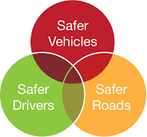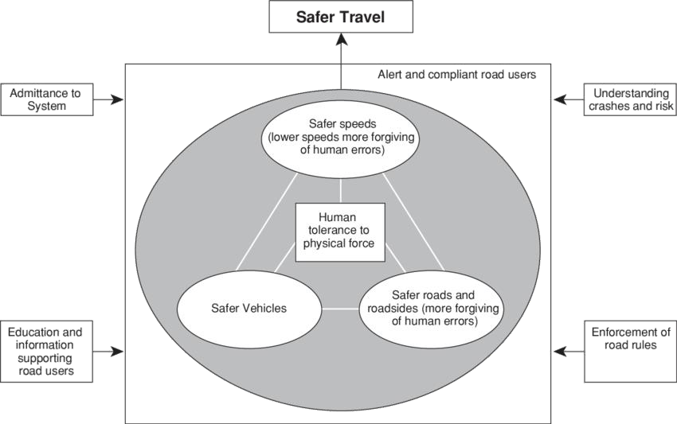

**Important Traffic Rules to Follow To Ensure Safety While Driving**

* Always wear a seatbelt.
* Avoid distractions.
* Do not cross the speed limits.
* Service your car regularly.
* Follow traffic signals.
* Maintain lane discipline.
* Be careful during bad weather.
* Maintain a safe distance.

Using new technology such as smart traffic light and traffic control systems, artificial intelligence, the use of AI chip and Sensor automotive technology can contribute to prevent and reduce the number of road related accidents and improve road safety.

3.2 **Ideation & Brainstorming**

**BRAIN STORM**

* zones dynamically set road signs speed vehicle based speed and lane display accident detection and diversion Timer displaying how much time for trafc to clear out
* Camera attached to every trafc sign to monitor trafc Schools timings set to road signs Camera monitors road quality and speed is assigned based on road quality Lane mapper so emergency vehicles can easily pass through trafc Remote view capability to plan route
* Using camera to measure visibility cloud server calculates speed for every point in map using open weather.

**GROUP IDEA**

* Group ideas Take turns sharing your ideas while clustering similar or related notes as you go. In the last 10 minutes, give each cluster a sentence-like label. If a cluster is bigger than six sticky notes, try and see if you and break it up into smaller sub-groups.
* cloud server calculates speed for every point in map Using camera to measure visibility AI based algorithms to predict weather from images AI based image processing to detect rain/ wet roads Camera attached to every traffic sign to monitor traffic Camera monitors road quality and speed is assigned based on road quality using open weather api to get data on weather Remote view capability to plan route Schools timings set to road signs Fun things to display during red light traffic Dynamic traffic sign capable of allowing peds to cross the road every sign post measures surrounding traffic emergency vehicles passage and alerts vehicle based speed and lane display School and hospital zones dynamically set road signs speed Timer displaying how much time for traffic to clear out accident detection and diversion Lane mapper so emergency vehicles can easily pass through traffic automatic traffic diversions sign color.

**PRIORITIZE**

## Prioritize your team should all be on the same page about what's important moving forward. Place your ideas on this grid to determine which ideas are important and which are feasible.

* Feasibility Regardless of their importance, which tasks are more feasible than others? (Cost, time, effort, complexity, etc.) If each of these tasks could get done without any difficulty or cost, which would have the most positive impact? Importance Schools timings set to road signs Fun things to display during red light traffic

## Dynamic traffic sign capable of allowing peds to cross the road sign color change based on environmental lighting conditions School and hospital zones dynamically set road signs speed vehicle based speed and lane display Lane mapper so emergency vehicles can easily pass through traffic accident detection and diversion emergency vehicles passage and alerts automatic traffic diversions Remote view capability to plan route using open weather api to get data on

3.3 PROPOSED SOLUTION

|  |  |  |
| --- | --- | --- |
| **S.No** | **Parameter** | **Description** |
| 1. | Problem Statement (Problem to be solved) | To replace the static signboards, smart connected sign boards are used which get the speed limitations from a web app using weather API and update automatically. |
| 2. | Idea / Solution description | Predicting the speed limit from data acquired through weather map and pass through a web user interface which in turn used by user |
| 3. | Novelty / Uniqueness | Controlling the speed limit by weather map. |
| 4. | Social Impact / Customer Satisfaction | Based on traffic diversion signs ,guide signs and warning signs are displayed to the public. |
| 5. | Business Model (Revenue Model) | Smart connectivity and better road safety model. |
| 6. | Scalability of the Solution | The process of understanding and operating this Model is easy and its highly scalable with proper efficiency. |

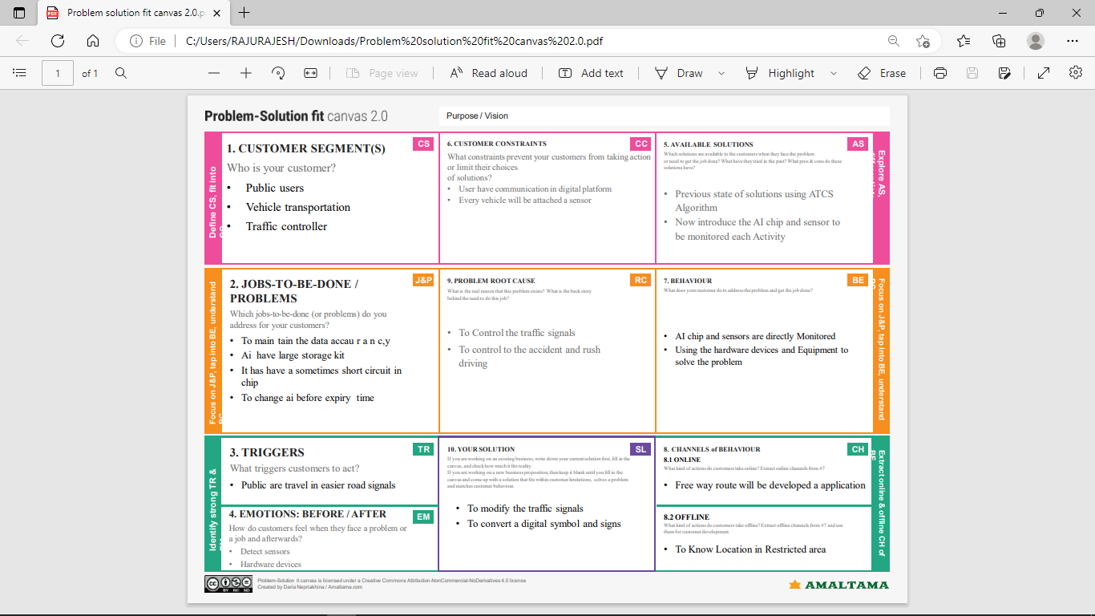3.4 PROBLEM SOLUTION FIT

4. REQUIREMENT ANALYSIS

4.1 FUNCTIONAL REQUIREMENT

4.1.1 SYSTEM TECHINCAL REQUIREMENT:

* Safe roads and roadsides – that are predictable and forgiving of mistakes. They are self-explaining in that their design encourages safe travel speeds and help avoid errors.
* Safe speeds – travel speeds that suit the function and level of safety of the road. People understand and comply with the speed limits and drive to the conditions.
* Safe vehicles – that prevent crashes and protect road users, including occupants, pedestrians and cyclists, in the event of a crash.
* Safe road users – road users that are alert and unimpaired, and who comply with road rules. They take steps to improve safety, and demand and expect safety improvements.
  + 1. SPECIFICATION:
* ROAD SAFETY MANAGEMENT- Preventing death and serious injury in road crashes requires a systematic, planned response, led by an appropriately resourced and accountable governmental leadership. Countries with the safest road networks have demonstrated political will by targeting better road safety outcomes, adopting and funding a systematic, evidence-based approach to intervention, and ensuring key organizational arrangements are in place
* RISK AND ISSUES IDENTIFY- Assessment of risk should be undertaken for the entire road network for which the road agency is responsible. In many countries, a small percentage of roads account for a large percentage of deaths and serious injuries. At program level, the task is to identify such routes and address these as a priority. There are established approaches for identifying high risk crash locations – but training of key staff is required. For existing road networks, where data is available, assessment of crash data should be undertaken to identify high risk locations (where data is available). To identify crash based locations good crash data is required. Proactive approaches should also be adopted – especially for major road corridors – including impact assessment, road safety audit, safety inspection, and road assessment program. Where crash data is not available, these proactive approaches must be adopted while collection of crash data commences. Proactive approaches should be used in combination with crash data where this is available. This combination of approaches provides a full assessment of road safety risk.

|  |  |  |  |
| --- | --- | --- | --- |
| **FR No.** | **Functional Requirement** | **Sub Requirement (Story / Sub-Task)** | |
| 1. | **User Visibility** | Sign Boards should be made with LED’s which are bright colored and are capable of attracting the drivers attention but it should also not be too distracting or blinding cause it may lead to accidents. | |
| 2. | **User Need** | The smart sign boards should be placed frequently in places it is needed and less in places where it is not needed much to avoid confusion for the user during travel. |
| 3. | **User Understanding** | For better understanding of the driver, the signs should be big, clear and legible and it can also include illustrations which will make it easily understandable to the driver. |
| 4. | **User Convenience** | The display should be big enough that it should  even be visible from far distance clearly. |

* 1. NON-FUNCTIONAL REQUIREMENT
  2. 4.2.1 SECURITY:
* **ALCOHOL DETECTOR** – if the driver is sensed to be alcohol consumed then the vehicle will not starts.
* **MOBILE SNIFFING SYSTEM**– during travelling, if he uses mobile phones then he/she is allowed to use not more than 15 seconds. Then a voice message about stop using mobiles will be given. If still he/she continues, the vehicle will get slow and stops.
* **EMERGENCY SYSTEM**– accidents occurs if any, then the accident is recognized using vibrating sensor and using GSM module the area where the accident took place is sent to emergency centers like 108, etc…
* **SECURITY SYSTEM**– if the vehicle is found to theft, then the user can identify the location where the vehicle now and stop the fuel flow as well as to activate the center lock of vehicle using GSM module.
  + 1. **PERFORMANCE:**
* Step 1: Identify the Testing Environment.
* Step 2: Identify the Performance Metrics.
* Step 3: Plan and Design Performance Tests.
* Step 4: Configure the Test Environment.
* Step 5: Implement the Test Design.
* Step 6: Run the Tests.
* Step 7: Analyze, Tune and Retest.
  + 1. **MAINTAINCE:**
* Always wear a seatbelt.
* Avoid distractions.
* Do not cross the speed limits.
* Service your car regularly.
* Follow traffic signals.
* Maintain lane discipline.
* Be careful during bad weather.
* Maintain a safe distance.
  + 1. **USABILITY:**

Traffic signboards provide important information, directions and warnings on the road they are designed and placed as assistance to drivers. They keep traffic flowing freely by helping drivers reach their destinations and letting them know entry, exit, and turn points in advance. Pre-informed drivers will naturally avoid committing mistakes or taking abrupt turns and causing bottlenecks. Comprehension of traffic signboards is crucial to safety, but they are not always detected or recognized correctly. Signboards present issues in terms of detection and recognition due to poor visibility, bad weather conditions, the color combinations used, their height and position, vehicle speed, and driver’s age and vision.

|  |  |  |
| --- | --- | --- |
| **FR No.** | **Non-Functional Requirement** | **Description** |
| 1. | **Usability** | It should be able to Upgrade and Update when there is a need for it. |
| 2. | **Security** | It should have good security system so that no other person is able to hack and display their own directions. |
| 3. | **Reliability** | It should be able to display to information correctly and error-free. |
| 4. | **Performance** | It should be able to automatically update itself  Using AI sensor and hardware chip |

**5. PROJECT DESIGN**

**5.1 DATA FLOW DIAGRAMS**

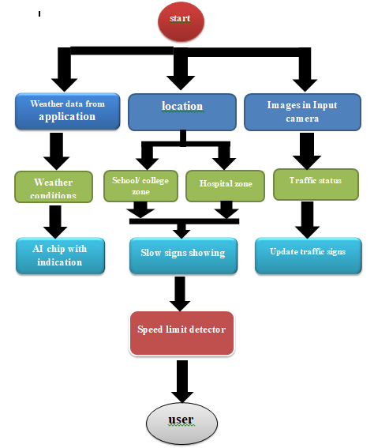

**5.2 SOLUTION & TECHNICAL ARCHITECTURE:**

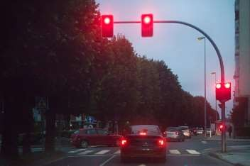

Application

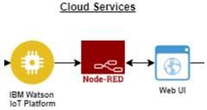

middleware

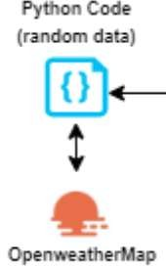

networking

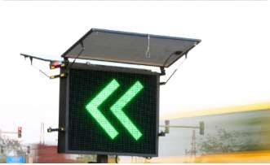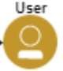

USER

5.3 USER STORIES:

In present Systems the road signs and the speed limits are Static. But the road signs can be changed in some cases. We can consider some cases when there are some road diversions due to heavy traffic or due to accidents then we can change the road signs accordingly if they are digitalized. This project proposes a system which has digital sign boards on which the signs can be changed dynamically. If there is rainfall then the roads will be slippery and the speed limit would be decreased. There is a web app through which you can enter the data of the road diversions, accident prone areas and the information sign boards can be entered through web app. This data is retrieved and displayed on the sign boards accordingly.

6. PROJECT PLANNING & SCHEDULING

6.1 SPRINT PLANNING & ESTIMATION:

|  |  |  |
| --- | --- | --- |
| **TITLE** | **DESCRIPTION** | **DATE** |
| Literature Survey& Information Gathering | A literature review is a comprehensive summary of previous researches on the topic. The literature review surveys scholarly articles, books, and other sources relevant to a  particular area of research. | 3rd October 2022 |
| Prepare Empathy Map | An empathy map is a collaborative tool teams can use to gain a deeper insight into their customers. It helps us to understand the customers’ pain, gain and difficulties  from their point of view. | 3rd October 2022 |
| Ideation- Brainstorming | Brainstorming is a group problem-solving  method that helped us to gather and organize various ideas and thoughts from team  members. | 3rd October 2022 |
| Define Problem statement | The Customer Problem Statement helps us to focus on what matters to create experiences people will love. A well-articulated customer problem statement allowed us to find the ideal solution for the challenges customers face. | 3rd October 2022 |

|  |  |  |
| --- | --- | --- |
|  |  |  |
| Problem Solution Fit | It helped us understand and analyze all the thoughts of our customer, their choice of options, problems, root cause,  behavior and emotions. | 21st October 2022 |
| Proposed solution | It helped us analyze and examine our solution more in the grounds of uniqueness, social impact, business model, scalability  etc. | 21st October 2022 |
| Solution Architecture | Solution architecture is a complex process – with many sub-processes – that bridges the gap between business problems and technology solutions. It helped us understand the features and components used to  complete the project. | 21st October 2022 |
| Customer journey map | It helped to analyse the various steps, interactions, goals and motivation, positives, negatives and  opportunities. | 22nd October 2022 |
| Solution requirements | It briefs about functional and non-functional requirements. It involves the various steps in the entire process. It also specifies features usability, security,  reliability, performance, availability and scalability. | 22nd October 2022 |
| Technology stack | A tech stack is the combination of technologies a company uses to build and run an application or project. It helps us analyse and understand various technologies that needs to be implemented in the  project. | 22nd October 2022 |

|  |  |  |
| --- | --- | --- |
| Data flow | A Data Flow Diagram (DFD) is a traditional  visual representation of | 22nd October 2022 |

|  |  |  |
| --- | --- | --- |
|  | the information flows within a system. A neat and clear DFD can depict the right amount of the system requirement graphically. It shows how data enters and leaves the system, what changes the information, and where data is stored. |  |
| Sprint Delivery plan | Sprint Planning is an event in scrum that defines what can be delivered in the upcoming sprint and how that work will be achieved. It helps us to organise and complete the work effectively and efficiently. | 13th november 2022 |
| Prepare milestone and activity list | Helps us understand and evaluate our progress and accuracy so far. | 13th november 2022 |
| Project Development - Delivery of Sprint-1 | Develop and submit the developed code by testing it. | In progress |

**6.2SPRINT DELIVERY SCHEDULE:**

Product Backlog, Sprint Schedule, and Estimation

Use the below template to create product backlog and sprint schedule

|  |  |  |  |  |  |  |
| --- | --- | --- | --- | --- | --- | --- |
| **Sprint** | **Functional**  **Requirement (Epic)** | **User Story**  **Number** | **User Story / Task** | **Story Points** | **Priority** | **Team**  **Members** |
| Sprint-1 | Registration | USN-1 | As a user, I can register for the application by entering my email, password, and confirming my password. | 2 | High | RAJESH |
| Sprint-1 |  | USN-2 | As a user, I will receive confirmation email once I have registered for the application | 1 | High | RAJESH |
| Sprint-1 |  | USN-3 | As a user, I can register for the application through Facebook | 2 | Low | RAJESH |
| Sprint-1 |  | USN-4 | As a user, I can register for the application  through Gmail | 2 | Medium | NAWAS  HUSSIAN |
| Sprint-1 | Login | USN-5 | As a user, I can log into the application by entering email & password | 1 | High | NAWAS HUSSIAN |
| Sprint-1 | Dashboard | USN-6 | As a user, I can log into the application by entering email & password and access all the  resources and services available | 2 | High | NAWAS HUSSIAN |

|  |  |  |  |  |  |  |
| --- | --- | --- | --- | --- | --- | --- |
| **Sprint** | **Functional**  **Requirement (Epic)** | **User Story**  **Number** | **User Story / Task** | **Story Points** | **Priority** | **Team**  **Members** |
| Sprint-2 | Login | USN-1 | As a weather data controller, I log into my profile and start monitoring the weather updates | 3 | High | BALAJI |
| Sprint-2 | Dashboard | USN-2 | I receive all the information about weather from web from weather API. Whenever there is change in weather, corresponding updates are  made on sign boards. | 2 | Medium | NAWAS HUSSIAN |
| Sprint-3 | Login | USN-1 | As a image controller, I keep note of all the images received from various areas and detect  traffic in that particular area. | 3 | High | SAMUEL |
| Sprint-3 | Dashboard | USN-2 | With the traffic, updates I change the status of sign board as “take diversion”. | 2 | Medium | SAMUEL |
| Sprint-4 | Login | USN-1 | As a zonal officer, I ensure that boards near school display “slow down” and near hospitals  display “no horn”. | 3 | High | MANI  KANDAN |
| Sprint-4 | Login | USN-1 | As an administrator, I ensure that all departments work co-ordinated and ensure the  accuracy and efficiency. | 2 | Medium | MANI KANDAN |

# Project Tracker, Velocity & Burn down Chart: (4 Marks)

|  |  |  |  |  |  |  |
| --- | --- | --- | --- | --- | --- | --- |
| **Sprint** | **Total Story Points** | **Duration** | **Sprint Start Date** | **Sprint End Date (Planned)** | **Story Points Completed (as on**  **Planned End Date)** | **Sprint Release Date (Actual)** |
| Sprint-1 | 20 | 6 Days | 14 Nov 2022 | 19 Nov 2022 | 20 | 19th november 2022 |
| Sprint-2 | 20 | 6 Days | 14 Nov 2022 | 19 Nov 2022 | 20 | 19TH  November 2022 |
| Sprint-3 | 20 | 6 Days | 14 Nov 2022 | 19 Nov 2022 | 20 | 19th November 2022 |
| Sprint-4 | 20 | 6 Days | 14 Nov 2022 | 19 Nov 2022 | 20 | 19th November 2022 |

**7. CODING & SOLUTIONING**

**7.1 FEATURE 1:**

PYTHON CODING:

from tkinter import*

base = Tk()

base.geometry("500x500")

base.title("WEATHER REPORT")

labl_0 = Label(base, text="WEATHER REPORT",width=20,font=("bold", 20))

labl_0.place(x=90,y=53)

lb1= Label(base, text="TEMPERATURE", width=20, font=("arial",12))

lb1.place(x=20, y=120)

en1= Entry(base)

en1.place(x=200, y=120)

lb3= Label(base, text="PRESSURE", width=20, font=("arial",12))

lb3.place(x=19, y=160)

en3= Entry(base)

en3.place(x=200, y=160)

lb4= Label(base, text="HUMIDITY", width=20,font=("arial",12))

lb4.place(x=19, y=200)

en4= Entry(base)

en4.place(x=200, y=200)

lb5= Label(base, text="Select SEASON", width=20, font=("arial",12))

lb5.place(x=5, y=240)

var = IntVar()

Radiobutton(base, text="RAINY", padx=5,variable=var, value=1).place(x=180, y=240)

Radiobutton(base, text="SUMMER", padx =10,variable=var, value=2).place(x=240,y=240)

Radiobutton(base, text="SPRING", padx=15, variable=var, value=3).place(x=310,y=240)

list_of_cntry = ("TAMILNADU", "ANDHRA", "KERALA")

cv = StringVar()

drplist= OptionMenu(base, cv, *list_of_cntry)

drplist.config(width=15)

cv.set("TAMILNADU")

lb2= Label(base, text="Select states", width=13,font=("arial",12))

lb2.place(x=14,y=280)

drplist.place(x=200, y=275)

lb6= Label(base, text="weather condition", width=13,font=("arial",12))

lb6.place(x=19, y=320)

en6= Entry(base, show='*')

en6.place(x=200, y=320)

lb7= Label(base, text="weather description", width=15,font=("arial",12))

lb7.place(x=21, y=360)

en7 =Entry(base, show='*')

en7.place(x=200, y=360)

Button(base, text="current status", width=10).place(x=200,y=400)

base.mainloop()

**7.2 FEATURE-2:**

**OUTPUT:** SCREENSHOT

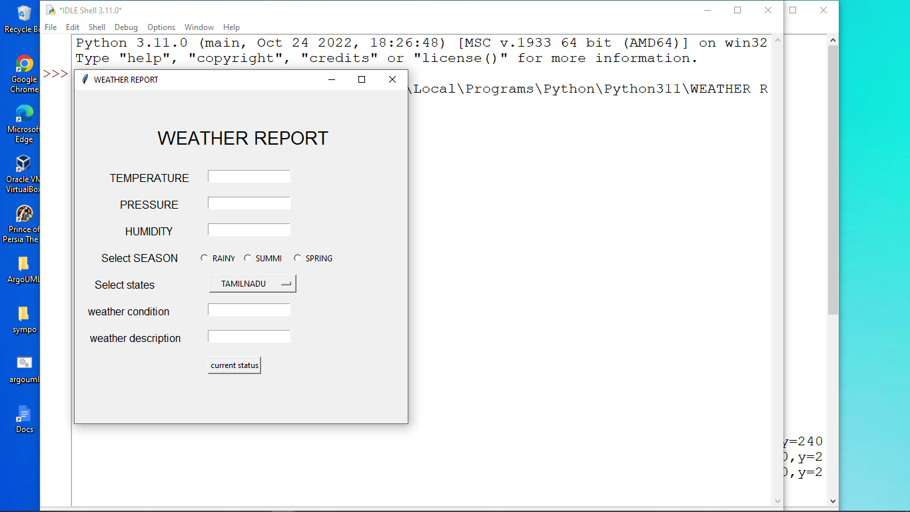

**7.3 SOLUTION:**

THUS THE PROJECT SOLUTION OF OUR ASSUMED WEATHER REPORT IS IDENTIFY AND RUNNING SUCCESSFULLY WILL EXCUTED AN OUTPUT.

**8. TESTING**

**8.1 TEST CASE:**

# Test Case Analysis

This report shows the number of test cases that have passed, failed, and untested

|  |  |  |  |  |
| --- | --- | --- | --- | --- |
| **Section** | **Total Cases** | **Not Tested** | **Fail** | **Pass** |
| Print Engine | 7 | 0 | 0 | 7 |
| Client Application | 51 | 0 | 0 | 51 |
| Security | 2 | 0 | 0 | 2 |
| Outsource Shipping | 3 | 0 | 0 | 3 |
| Exception Reporting | 9 | 0 | 0 | 9 |
| Final Report Output | 4 | 0 | 0 | 4 |
| Version Control | 2 | 0 | 0 | 2 |

8.2 USER ACCEPTANCE TESTING:

**Acceptance Testing**

**UAT Execution & Report Submission**

|  |  |
| --- | --- |
| Date | 25 November 2022 |
| Team ID | PNT2022TMID277860 |
| Project Name | Project: IOT- SIGNS WITH SMART CONNECTIVITY BETTER ROAD SAFTY |
| Maximum Marks | 4 Marks |

# Purpose of Document

The purpose of this document is to briefly explain the test coverage and open issues of the [Product Name] project at the time of the release to User Acceptance Testing (UAT).

# Defect Analysis

This report shows the number of resolved or closed bugs at each severity level, and how they were resolved

|  |  |  |  |  |  |
| --- | --- | --- | --- | --- | --- |
| **Resolution** | **Severity 1** | **Severity 2** | **Severity 3** | **Severity 4** | **Subtotal** |
| By Design | 10 | 4 | 2 | 3 | 20 |
| Duplicate | 1 | 0 | 3 | 0 | 4 |
| External | 2 | 3 | 0 | 1 | 6 |
| Fixed | 11 | 2 | 4 | 20 | 37 |
| Not Reproduced | 0 | 0 | 1 | 0 | 1 |
| Skipped | 0 | 0 | 1 | 1 | 2 |
| Won't Fix | 0 | 5 | 2 | 1 | 8 |
| Totals | 24 | 14 | 13 | 26 | 77 |

**9. RESULTS**

**9.1 PERFORMANCE METRICS:**

• **Metric:** The output of an ongoing calculation performed as a “vehicle under test” is operated. • Reflects safety-related interactions with other road users and other dynamic elements.

• **Models:** Many metrics use models (mathematical descriptions) of the expected motion behavior of other traffic and/or the vehicle under test.

• **Example:** Time to collision is a metric computed at time ‘0’ using one of many models:

• Both vehicles remain at their current speeds (TTC), or

• Both vehicles remain at their current accelerations (TTCa), or

• Other traffic may suddenly maneuver, within specified bounds. Use of metrics for Safety Evaluations Motion Behavior Models

•ego vehicle

•other vehicles

•VRUs

•other dynamic elements Test data Metric calculations Subject vehicle (SV) Principal other vehicle (POV) Distance Time TTC:

**10. ADVANTAGES AND DISADVANTAGES**

**ADVANTAGES:**

* Reduces driving risks.
* Improves your driving skills.
* Accident free techniques.
* Maximum protection.
* No violation charges.
* Less maintenance
* Save on insurance cost.
* It is the most profitable. Road transport is the cheapest means of transport available.
* It is the fastest and most agile
* Flexibility of schedules and volumes
* Maximum traceability.
* Door-to-door service
* Easy paperwork
* Accident rate.
* Less load capacity.

**DISADVANTAGES:**

* It’s expensive.
* If not practical for all roads.
* In perceived by some as a way of raising funds.
* It less or no effect beyond the camera.
* They are subject to vandalism.
* In need regular maintenance.
* Vulnerable to Season and Weather Impacts: Road transport infrastructure and travel is vulnerable to weather changes and seasons
* Accidents and Breakdowns
* Not the Best Option for Long Distance and Heavy Cargo
* Slow Speed
* Lack of Organization and Structure

**11. CONCLUSION**

The analytical process started from the public user to avoid the accidents and using the digital signs in roads ways of exploratory analysis and finally model building and evaluation. The best accuracy on public test set is higher accuracy score will be find out by comparing each algorithm with type of all smart buses for future prediction results by finding best connections. This brings some of the following insights about the priority based seat allocation and special seats for special person. To presented a prediction model with the embedded system of hardware and sensor to improve over human accuracy and provide with the scope of early detection. It can be inferred from this model that, area analysis and use of sensor technique is useful in developing prediction models that can helps to reduce the accident rate and self sucide.

**12. FUTURE SCOPE**

* Using IOT with hardware and sensor of AI chip used
* Simplify the bus routes and increases branching
* Increase bus speed with off-board fare collection, dedicated bus lanes and signal priority.
* Smart bus using latest addition to the concept of intelligent transport system that promises even better travel experience.
* Give bus routes, and reduce branching then three transport challenges are congestion, sprawl and cost.
* Traffic management measures, effective use of bus services.
* Parking restrictions and sprawling cities and large fleet cost.
  1. **APPENDIX**

SOURCE CODE: https://github.com/IBM-EPBL/IBM-Project-11806-1659346963/commit/2ebd8d0c9b532cff4d5cacf9093b5679d0637684

GITHUB & PROJECT DEMO LINK:

https://github.com/IBM-EPBL/IBM-Project-118061659346963/tree/main/IBM%20projects/TEAM%20MEMBERS

https://youtu.be/kjmIIOUs3LM